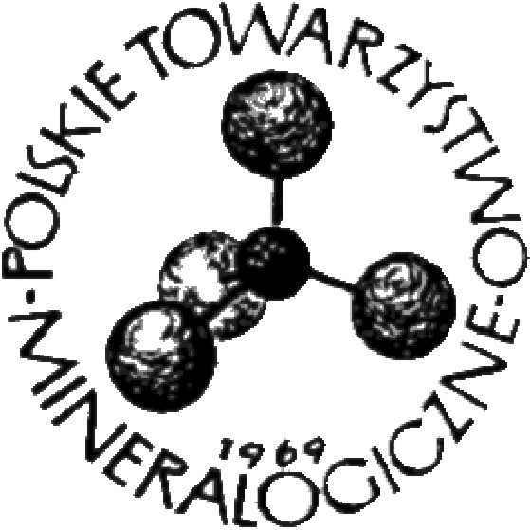
MINERALOGIA - SPECIAL PAPERS, 51, 2023
www.mineralogia.pl
MINERALOGICAL SOCIETY OF POLAND
POLSKIE TOWARZYSTWO MINERALOGICZNE
__________________________________________________________________________________________________________________________

Title of the abstract; Arial, 11, bold; alignment to the left margin

Name SURNAME¹, Name SURNAME²

¹Department of Geology, University …. , Address ……; e-mail:
²Department of Mineralogy, University ….., Address …..; e-mail:

Introduction
Please ensure that your abstract fits into one page and follows Instructions to Authors. (http://www.mineralogia.pl/EM_authors_info.html). Authors of invited lectures are asked to consult the size of abstracts with the Conference organizers. Please formulate your abstract by careful overwriting of this template file.

Instructions to Authors
Fonts. Title: Arial – 11pt, bold; Authors names and surnames – Times New Roman, 9 pt; Authors affiliation – Times New Roman, italics, 8 pt, Section titles (not mandatory) – Times New Roman, 10 pt, bold; Figures captions and tables (both caption and content) – Times New Roman, 9 pt; Text – Times New Roman, 10 pt.
Page layout. Margins: left and right - 4 cm, top and bottom – 4.8 cm. Indentation left – 0.5 cm; spacing before each section – 10pt; single line spacing.
Alignment. Title, Authors names and surnames, affiliation – to left margin. Text – to both the left and right margins.

Table 1. Caption of the table
 | Column 1 | Column 2 | Column 3 | Column 4
Row 1 | 234.56 | 456.78 | 567.89 | 789.00
Row 2 | 23.8 | 56.78 | 8.9 | 0.8

Fig. 1. Simplified geological map of the sampling area

If necessary, use text wrapping around object (figure, table). Please note that the number of colour pages in the abstract book is very limited. Acknowledgements are not mandatory.

References
Pyle, J.M., Spear, F.S., Rudnick, R. L., McDonough, W.F. (2001). Monazite-Xenotime-Garnet Equilibrium in Metapelites and a New Monazite-Garnet Thermometer. Journal of Petrology, 42(11), 2083–2107.

